Theatre Etiquette Stage Locations:
True or False
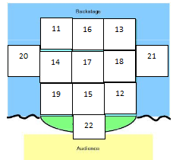
1. It is ok to give advice to fellow actors about blocking
2. If I see a prop during the show that is in a new spot I can put it in the old spot.
3. There are no “stars in a show” everyone is needed
4. A dentist appointment that I planned months ago is a valid reason for missing a rehearsal.
5. I can’t do my job when others don’t do their job.
6. Gossip is unwelcome in the theatre.
7. if something falls, pick it up.
8. if someone breaks it is ok to break.
9. The only place to eat food props is on the stage.
10. It is ok to peek through the curtains if it is between acts and the lights are off.

Theatre Etiquette Stage Locations:
True or False
1. It is ok to give advice to fellow actors about blocking
2. If I see a prop during the show that is in a new spot I can put it in the old spot.
3. There are no “stars in a show” everyone is needed
4. A dentist appointment that I planned months ago is a valid reason for missing a rehearsal.
5. I can’t do my job when others don’t do their job.
6. Gossip is unwelcome in the theatre.
7. if something falls, pick it up.
8. if someone breaks it is ok to break.
9. The only place to eat food props is on the stage.
10. It is ok to peek through the curtains if it is between acts and the lights are off.

